Historical Information Regarding Peaks (“On-peak”)

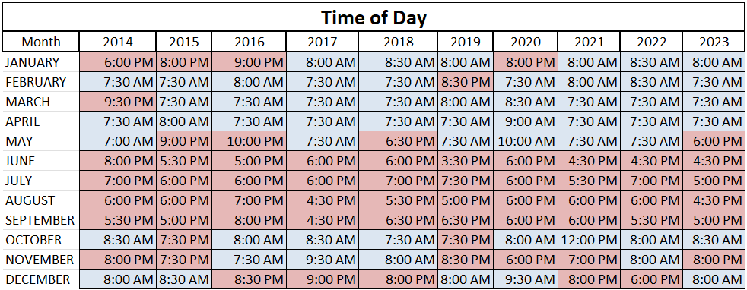

- In the summer months (June through September) our peaks were between 4pm and 8pm 98% of the time.
- Outside of the summer months, 84% of the peaks occurred between 7 and 9 (could be AM or PM with AM being more probable)
- 87.5% of our peaks occur on weekdays as opposed to weekends.

